**Learning Plan**

**Exploring Individual Passions and Identity through Stories, Art, and Collaboration**

**Jessica Smith**

**V0013351**

**Kindergarten**

|  |  |
| --- | --- |
| “The RAVEN’S gift to the learning process is cleverness and imagination. The Raven weaves together old, new and emerging knowledge to create a basket of skills, opportunities and potentials. When the Raven’s gifts are accessible to students and they are able to integrate them into their learning experiences, they have more opportunity to develop their inherent talents and capabilities. A key principle of the Raven’s gift to the learning process is recognizing that story-telling, art, memory and culture are woven throughout learning. In order to experience this, learners need to see themselves reflected in all aspects of the learning environment.”[[1]](#footnote-1) | Photo by Peter Lloyd on Unsplash.jpg  Photo by Peter Lloyd on Unsplash |

This learning plan is designed to occur after the first few weeks of school beginning in September. Prior to implementing this plan, picture books and oral stories would be chosen that highlight really passionate story book characters with strong identity themes, such as “Chrysanthemum,” or “Ada Twist and the Perilous Pants” that have similar interests and passions to those of the students. Students will be encouraged to look at themselves, their names, their families and their connections within their communities. The lessons will not explicitly say so, but by building on themes of identity, family and community students will hopefully see that we are all connected. By sharing personal stories of my own family and identity as a child and encouraging students to feel comfortable to share their own stories and experiences, I hope to build trust and relationships. To facilitate community and establish clear boundaries for relationships and classroom expectations, I will introduce the ideas presented by First Nations called “The Spirit of Alliances: A journey of good hearts and good minds,”[[2]](#footnote-2) which describes four Indigenous animals; the salmon who never gives up, the wolf who teaches about relationships, the raven who teaches us that we all have a special light or gift to share, and the bear who teaches us about self-regulation.

With a sense of community and relationships forming in the classroom, the purpose of this learning plan is to explore identity and individual passions of each student through story workshop, writing, drawing, colouring and painting. The students will be encouraged to photo- document their work and ideas with a digital camera. Throughout the process, students will be encouraged to try to write words to represent their thoughts and ideas of what they were trying to express. I can write down their ideas if needed using their words only. To get the students used to painting and drawing, some guided instruction will occur, but the majority of learning will be through purposeful play. The end of this learning plan will be a painting/drawing done in collaboration where each student represents one of their passions in a group painting. The background of the painting will have a heart to represent how our passions develop from what we love. (Please see example done at the end of this lesson plan, created by my family to get a better idea of what this will look like.) I will create a background painting that will be cut up into squares, depending on how many students and families there are, so that each student can create an individual square that represents one or more of their passions. After the students have completed their work, families potentially will be invited during a café night to complete another square of art representing what the family is passionate about to add to the collaborated artwork. The café night will display the student’s favourite writing, painting, drawing or photograph that represents their favourite expression of themselves and their passion. This café night is a celebration of the learning up to this point, but the theme of identity and passions will continue on throughout the year as I encourage the students to learn through the inquiry process.

**Big Ideas**

1. Curiosity and wonder lead us to new discoveries about ourselves and the world around us.
2. Stories and other texts help us learn about ourselves and our families.
3. Stories and other texts can be shared through pictures and words.
4. Everyone has a unique story to share.

**Curricular Competencies**

Using oral, written, visual, and digital texts, students are expected individually and collaboratively to be able to:

Comprehend and connect (reading, listening, and viewing)

* Engage actively as listeners, viewers, and readers, as appropriate, to develop understanding of self, identity, and community
* Recognize the importance of story in personal, family, and community identity
* Use personal experience and knowledge to connect to stories and other texts to make meaning

Create and communicate (writing, speaking, and representing)

* Exchange ideas and perspectives to build shared understanding

**Content**

Students are expected to know the following:

* Story; structure of story
* Strategies and processes; reading strategies and metacognitive strategies

**First People’s Principle**

* Learning requires exploration of one’s identity.

The ideas presented in this lesson plan connect strongly to parts of the curriculum in every subject except math and science. For instance in “Applied Design, Skills, and Technologies” this learning plan connects to the big idea that “Skills can be developed through play”. For “Arts Education” we connect to the big ideas that “Skills can be developed through play,” “Engagement in the arts creates opportunities for inquiry through purposeful play,” and “People connect to others and share ideas through the arts.”

**Learning Plan Sequence Overview**

1. Every day we will read picture books and include oral stories that explore children’s passions and identity. Suggestions for picture books are at the end of this lesson plan. Through the days of the week, a student will be chosen to bring in a show and tell item to share with the class. This student will present their item and share it with the class.

|  |  |
| --- | --- |
| 1. We will read the story “Beautiful Oops!” by Barney Saltzberg. Students will be encouraged to play at one of three work stations using watercolour paint to colour a drawing done in fine tip sharpie. Each station will have two primary colours. No meaning is expected out of this lesson. It is purely about playing with the paint and discovering what they can come up with. | https://lh6.googleusercontent.com/_XQsW_zQPRrjv-zE-N34WYP6f5xnvSLSq0E25Wn4Dv-IBFj1zu0Ue_9H2F-FF5yTB6p1Vm7-t9-byfBwBBWijaowxsdUmZrbV3YIpR79aFaGNeY6lwtgbrFFEQD8a7gN6w8wQY31 |

1. Passions and story will be further explored through story workshop. Each student will have their own wooden figure with their photo glued on to it with a variety of materials such as rocks from the beach, little pieces of wood, beads, and craft supplies on coloured pieces of fabric to create their own story about themselves and their interests or passions. Students will be encouraged to create a written or oral story about the adventures they create during story workshop. The students will take photos of what they created and these photos will be uploaded to FreshGrade, along with any text the students would like to use to describe what they created.
2. Read two of the student’s favourite picture books on passions. Have a group discussion with students about what their passions might be. I will model what my passions were as a child and now as an adult. We may spend several lessons doing this exploring of passions, depending on the student experience. Four stations will be set up for students to explore their passions and themselves. 1. Clip board, paper and black sharpie, colour markers. 2. Clip board, paper, crayons, and acrylic gauche. 3. Clip board, paper, fine tip sharpie and pencil crayons. 4. Clip board, paper, fine tip sharpie and watercolour pencil crayons. Some guided instruction may occur depending on the class. I will photo-document the process of individual work and post images, including a written description of what each student says about each image on Freshgrade for parents to view. I will discuss the results of each project individually with each student either at the time they are doing it, or later while viewing the photograph of their work.

|  |  |  |
| --- | --- | --- |
| Norah Smith, 5 years old | E:\Files\Jess\JM Imagery\teaching\Poppet Art Classes\wc pencils kids\images\Norah age 5 owl72 no words.png  Norah Smith, 5 years old | IMG_1086.JPG  Bird Portraits Explored in Kindergarten Class Using Fine  Tip Black Sharpie and Pencil Crayon |

Each student will pick their favourite artwork to be displayed at a café night for parents and family to view. Student will be encouraged to write down ideas of their passions if possible. If students are not able to write, I will write down what the students tell me to write about their passions to provide understanding for the gallery viewing.

1. The last of project of this learning plan will be a collaborative piece of art. I will draw a heart outline with pencil for a background similar to the one in the sample I have included at the end of this learning plan. I will then cut the painting up into squares, and number each square so I know where it fits in the final piece of artwork. Each student will be given a square to draw and paint their individual passions on, tying into the heart outline where needed.

At the end of this learning plan with be a café gallery night, where family and friends come to view student work, families will be encouraged to complete a square for the collaborate piece of art. To prepare parents before the café night, parents will be given a letter explaining what the art project is about and how they are to create an image that represents a family passion. Families will only participate if they want to. The pieces of art will be glued on to wooden panel that will be later hung on the wall. The final artwork panel will be varnished so it can be easily wiped down and protected. This artwork will be displayed on the wall of the classroom for the rest of the school year.

**Environment**

This learning plan will take place in the classroom. Ideally the classroom will be set up with round tables and a carpet for story time. The ending café night will occur in the classroom. Artwork will be displayed in the classroom on bulletin boards. During the café night there will be art stations set up for families to create a square for the final collaborate artwork representing everyone’s passion.

**Materials**

Materials used for this learning plan begin with the use of picture books to inspire ideas and imagination. A list of books has been supplied at the end of this learning plan. To further explore these ideas, multimodal ways of learning will be encouraged using story workshop, painting, and drawing. For story workshop a variety of materials will be used including small wooden figures from Lee Valley, beach rocks, driftwood, feathers, a variety of craft materials and round cut pieces of fabric to create their stories on top of. For instance blue fabric could represent the water and brown fabric could represent soil or quicksand. For painting and drawing techniques, we will use regular pencil crayons, watercolour pencil crayons, a variety of black sharpie markers, brushes, and watercolour paint with Canson XL watercolour paper. All paper creations will be mounted on a clip board during the creation process. I would hope to have access to Ipads or some kind of digital camera for the students to be able to document their own work. Each student would have their own name tag to use in the photo documentation, so I know it was them that took the photo. I would have my own digital camera as well to document student work during the process.

**Adaptations**

Depending on the students in the class, some of the projects may have to be adapted to make it easier for some students to participate. Before I begin here, I must explain that the expectations for this learning plan are about process and exploration. There is no expectation for students to produce realistic representations of their ideas. If students are frustrated and would like help with their representation of their ideas, I will offer guidance and support. If a student has trouble holding a brush, pen or pencil due to gross motor control issues, I will include some brushes and markers with bigger handles. If any student has allergies to paints, I will have gloves available to use. If a child is allergic to the smell of sharpie markers, I will have other options available for students to use. If a student has extreme disabilities, anxiety, trauma or brain abnormalities that prevent them from taking part I will support this student to pair up with another student who is able to draw or paint their ideas for them. If the student is not able to express themselves with the materials presented, I will encourage students to photograph their passions and interests, or to find pictures in magazines that they can cut out that represent their ideas.

**Extensions**

Exploring student passions does not end at the café gallery night. Passions will continue to be explored throughout the year in every subject using inquiry based teaching methods. This learning plan is about discovering what student’s passions are, so that I can develop future learning plans around what these individual interests are. Students are more likely to be engaged in school learning when the material is relevant to what their interests and passions are outside of school.

**Assessment**

In order for students to understand the goals of the project and to ensure that they are meeting their potential, I will begin by setting clear goals and criteria before each new lesson begins, with group discussions and a list of goals in the front of the room. I will make sure to talk to students individually while the exploring is taking place, keeping clear notes of what the students say about their work in a clip board I carry around. If the student is able, I will encourage students to write down their passions and stories they create around these passions. I will photo document the process and upload the information on to Freshgrade for parents to see what the students are doing at school. If I find that I haven’t had a chance to speak individually with each student during the lesson, I will make time to speak to each student individually during silent reading.

After the first set of stations where students explore their ideas in drawing and painting, depending on the group, students will meet in groups of two and discuss using the TAG assessment method. TAG method stands for; **t**ell them something you like, **a**sk a question, and **g**ive the artist a positive suggestion. We will discuss this method beforehand and I will not proceed with this assessment method until I am confident that each student understands how this assessment works and the importance of not being negative. This TAG assessment method will occur after the first set of stations that the students do to explore individual passions, before they do a second session so that they can learn from their first experience. If I am not confident in the students and peer assessment, I may instead facilitate a group discussion of student work led by my guided questions so that students can be inspired and learn from each other.

The final assessment will happen at the café gallery walk in the classroom where I will assess the individual images that students have chosen to display. I will also do a final assessment on the effort and ideas behind the collaborative artwork created to hang on the classroom wall. All work created will be assessed on clarity of passions identified, engagement, thoughtfulness, effort and whether or not students have connected to the curriculum as outlined in this learning plan.

**Here are the links to online information for the First Nations stories that describe the bear, the raven, the salmon, and the wolf:**

The Spirit of Alliances: A journey of good hearts and good minds: <https://documents.sd61.bc.ca/ANED/educationalResources/SpiritOfAlliances/Aboriginal_Education_Enhancement_Agreement_2013-2018_GVSD.pdf>

The online book “The Four Stones” by Laurie Bayly:

<https://documents.sd61.bc.ca/ANED/educationalResources/SpiritOfAlliances/The_Four_Stones_Story_by_Laurie_Bayly.pdf>

**Appendix One –** Samples of Exploring Passions in Collaborative Paintings

|  |  |  |
| --- | --- | --- |
| This image is created by Greg Smith and represents his passion for soccer. | family passions.jpg**Smith Family Collaboration of Passions** | This image is created by Norah Smith (11 yrs old) and represents her passion for penguins and for writing non-fiction stories; this character is called, “Jim the Penguin.”  This image is created by Jessica Smith and represents her passion for cats and family. Each cat represents one of her family members including her cat and the children’s fish. Jessica also loves colour and drawing. |
| This image is created by Thomas Smith (13 yrs old) and represents his passion for creating creatures out of his imagination and his love for drawing. |
|  |  |

|  |  |
| --- | --- |
| heart collaboration rebecca.jpg Collaborative Artwork of Passions by Rebecca Bathurst-Hunt’s Kindergarten Class | jay image.jpg  Collaborative Artwork of George Jay’s Teaching Staff and their Passions as facilitated by Rebecca Bathurst-Hunt |

**Appendix Two -** Picture Books to Explore Learner’s Passions and Identity:

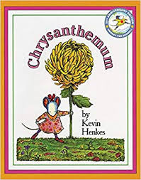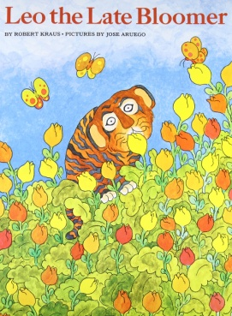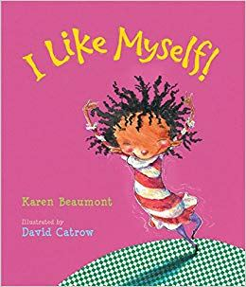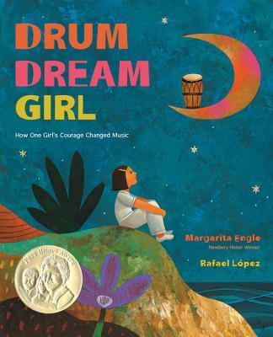

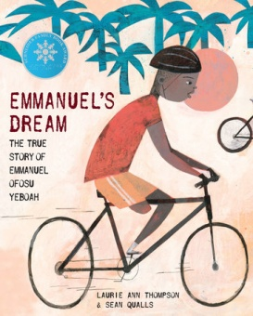**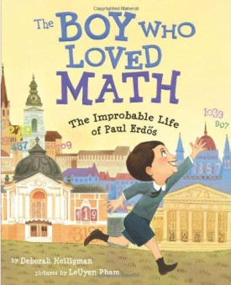** 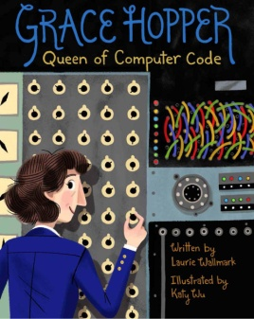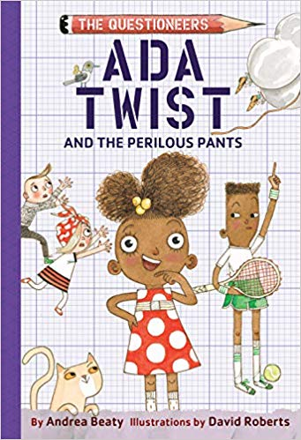

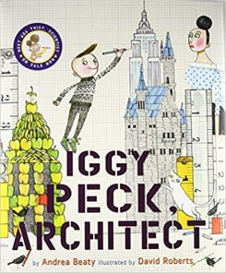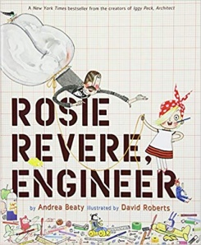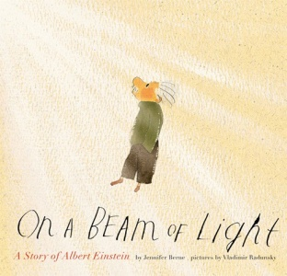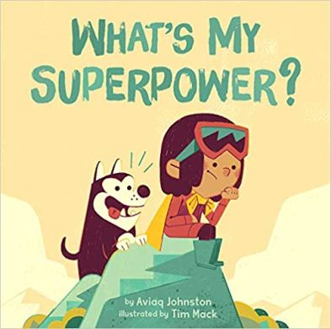

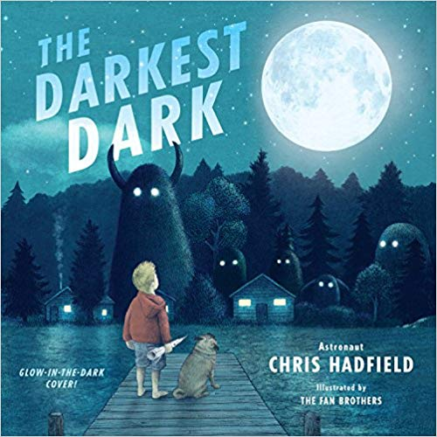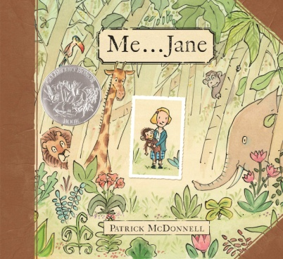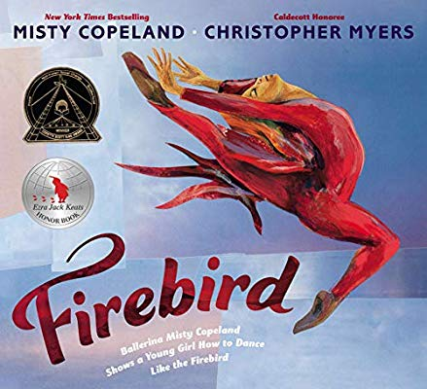

1. <https://documents.sd61.bc.ca/ANED/educationalResources/SpiritOfAlliances/Aboriginal_Education_Enhancement_Agreement_2013-2018_GVSD.pdf> [↑](#footnote-ref-1)
2. <https://documents.sd61.bc.ca/ANED/educationalResources/SpiritOfAlliances/Aboriginal_Education_Enhancement_Agreement_2013-2018_GVSD.pdf>, p. 8. [↑](#footnote-ref-2)